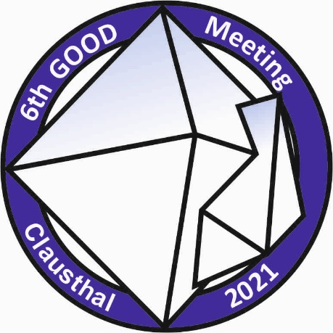


Registration GOOD Meeting 2021 Clausthal

Name (surname, name)

Address (street, postcode, city, country)

Contact Details (email address)

and/or

Affiliation
Institution

DMG student member yes no

Participation
Oral presentation
Poster presentation
Only registration

Title of presentation

Social Events
I would like to join the icebreaker (06.10.2021)

I’m interested in the seminar (ore microscopy (08.10.2021, afternoon, 10 participants)

I'm interested in the fieldtrip (not included in the conference fee)

Please send your completed form (and abstract) to jonas.alles@tu-clausthal.de

