How to Do:

Upload to Media.UP

Brief overview::
If you own the copyright to the video or audio file, you may want to upload it to Media.UP to share with your students or even anyone who has access to Media.UP. After logging in with your regular university account, you can access the upload section. You will have the option to select a specific file from your computer. You will then be guided through the process of adding additional information to the file and tagging it with keywords so that it can be found on the platform. After confirmation, your file will be uploaded. You will receive an email when it is finally available.

Note: You should watch this Video Tutorial on uploading in Media.UP, as it is based on an older version of Media.UP and therefore may look slightly different.

Detailed description how to upload a file to Media.UP
1. | Log in with your university account - you will find the icon in the upper right corner | 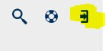
2. | To upload a file, click on the Upload button that appears after you log in at the top center
3. | Click Browse to select a file from your computer. Please note that the current upload size is limited to 10 GB. All common file types can be selected. | 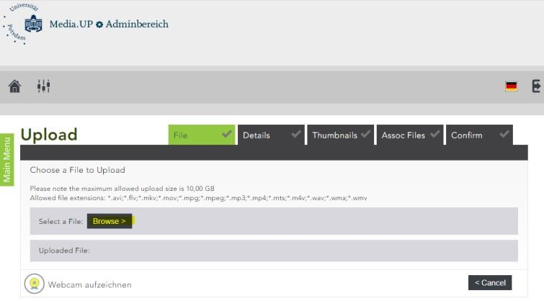
4. | Wait until your file is uploaded and then click the Next button  Fill in the fields and be sure to choose the appropriate category - there are quite a few! If you want to share the video, you need to set the category to something other than "Personal" (Private)" | 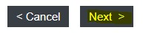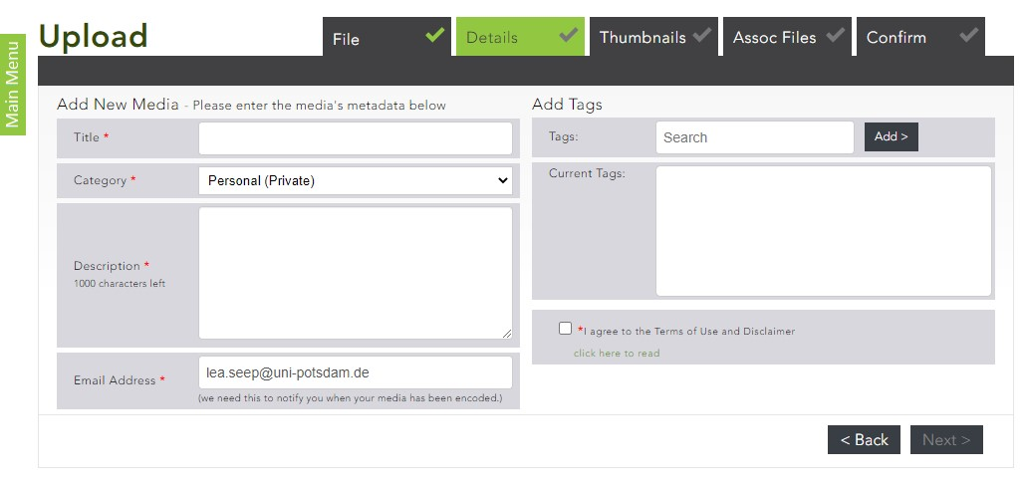
5. | Tag your upload. To do this, you can enter the tag you want in the search window. This will automatically search for existing tags that you prefer, as they can link all videos to that tag and redirect viewers from the other video to yours. You can also create a new tag. The tags are also important if you want to be found by the search function, as it searches all tags! | 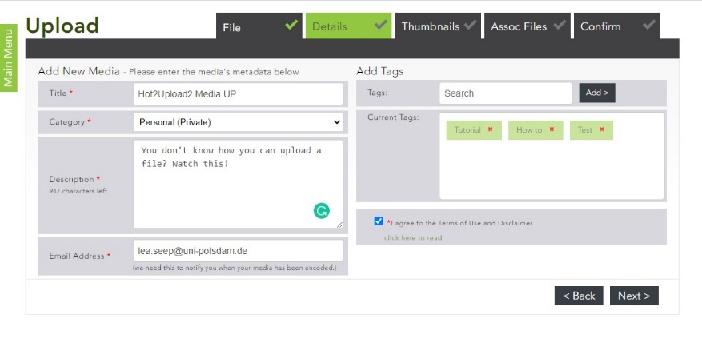
6. | You have several options for thumbnails, which is the image that appears on the search page, at the top of the video. You can choose automatically created thumbnails, upload a thumbnail you create yourself, or choose the "category thumbnail" that lets you know the file is a movie (in this case). Note that an appealing thumbnail can attract more viewers. | 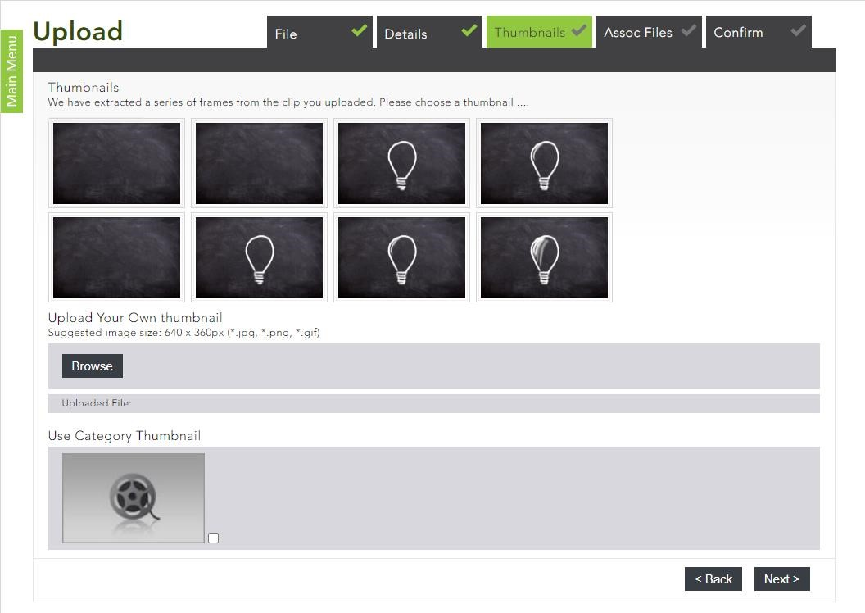
7. | If you have related files (a script, handout, etc.) that you want to attach, you can upload and attach them now. If you do not want to attach any additional content, simply click "Next". | 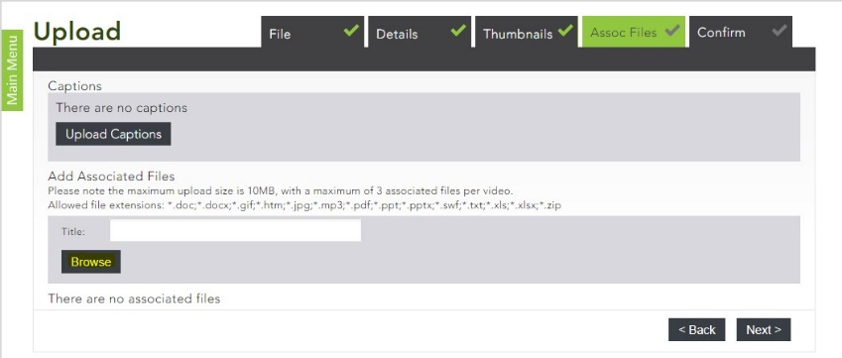
8. | In the last step you will see an overview of your overview and all additional details you just created. Click "Finish" to finally upload your video to Media.UP - the file will now be encoded (can take up to hours) You will receive an email from MediaUP once your video is ready | 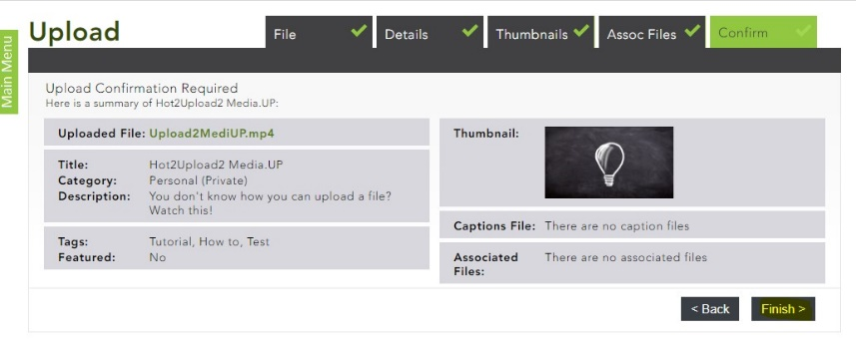
9. | To see an overview of your uploads, you can click the Upload button again (step2) and then go to the "Admin Area" (upper left corner) | 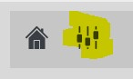
10. | Click on "Content" to see an overview of your content; clicking on "Content" will show details about your videos (e.g. how many times it has been viewed, etc.) | 