
How to Do:

Basics with PowerPoint

  - Brief instruction:
This PowerPoint crash course will include the usage of templates, how to import and link Excel charts and general tips for a good presentation. This was originally created for the Master course Toxicology but should the fit the basic needs for anyone just started working with PowerPoint. For more support please refer to online resources.

Note: if you do not have PowerPoint yourself, you can get it based on a Campus License from the University of Potsdam. See here for instructions.

  - Using a PowerPoint Template
A template file provides a general layout for your slides and to which you should stick if provided. For usage simply download the .pptx file. University Potsdam specific templates can be found here. Please check if you are allowed/ should use these!
1. | To open the template file, double click on the file
2. | Depending on your template you can choose from different slide types, you can see all options whit a click on the text “New Slide”  Note: the University only provides one style without any specified textboxes
3. | You can add textboxes by clicking on the “textbox” symbol and specifying the size of respective box | 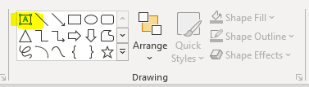
4. | Note: if you are given a template do NOT change the design but rather use a slide without the design if needed (e.g. a figure that cut the margins etc) | 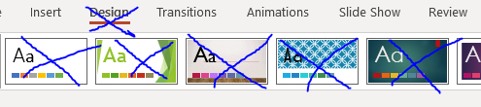

  - Import and link PowerPoint and Excel
1. | To insert a graph created in Excel (or a table) copy + paste respective element from Excel directly to PowerPoint
2. | Powerpoint recognizes Excel and gives you the chance to adjust for example the design of the table (note the new Tab “Chart Design”) | 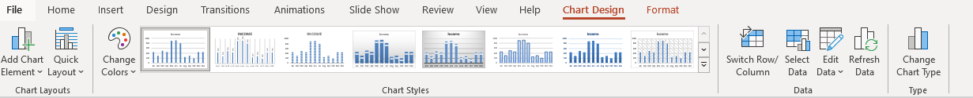
3. | (optional) The tab “Chart design” gives you plenty of options to change the layout or even the data (This will bring you back to your Excel source) | 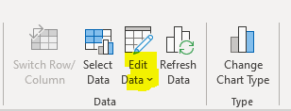
4. | (optional) The tab “Format” offers to adjust colours, background colours of the plot itself or its legend | 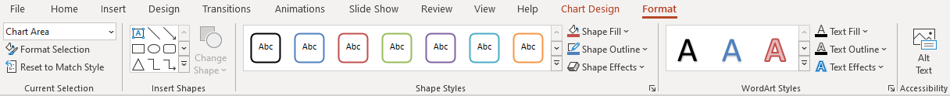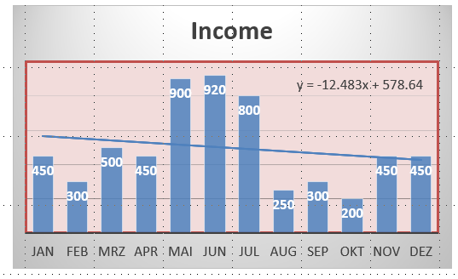
5. | Note: You got the optional changes only for elements generated with a MicrosoftOffice and directly inserted form this source, a screenshot won’t be able to be edited in such way. Such will be handled as picture

  - General Tips for presentations
1. | Ensure that you mark pictures and citations whenever it is not your personal property
2. | Make sure to not overcrowd your slide
3. | You can calculate 1~2 minutes per slide. (If the audience has to read a paragraph it won’t listen to you at the same time. At the same time you should last on each slide long enough for the audience to look at the entire slide – this in turn will limit the total number of your slide.)
4. | Make sure you fit the required time limits – you should practice this
5. | Keep your slide as simple as possible and easy to follow, prefer bullet points or keywords before sentences
6. | Moreover, do not go crazy with slide transitions, colors or such thing as word art. It’s fun but not the (Power)point.
7. | Make sure (BEFORE) that the presentation computer has PowerPoint installed otherwise you have to export your presentation in a different format (Be aware that this export might change colors, formatting, slide transitions etc. – PDF is a save format to go as it is a standard format however no slide transformations or animation are possible with pdfs!)
8. | If you have 2 screens (Beamer and Computer) and the Beamer is recognised as second screen you might want to use the presenter View as you can see your notes and a timer.
9. | If you present over Zoom, and only have one screen you can still have the option to see the presenter View while all others see the slides only. For this make sure you share PowerPoint first and then click “Alt-F5”.

