Light.Metal.Reactions 2026, Submission Title

Author 1¹*, Author 2¹, Author 3², etc.
1. Affiliation 1
2. Affiliation2
* Presenting author

Abstract: The abstract should have no more than 100 words.

This is a sample document which should give a good overview of the submitted contribution. The document should provide a concise impression of the contribution and, ideally, consist of a single page. The document may contain figures and tables with a respective captions.

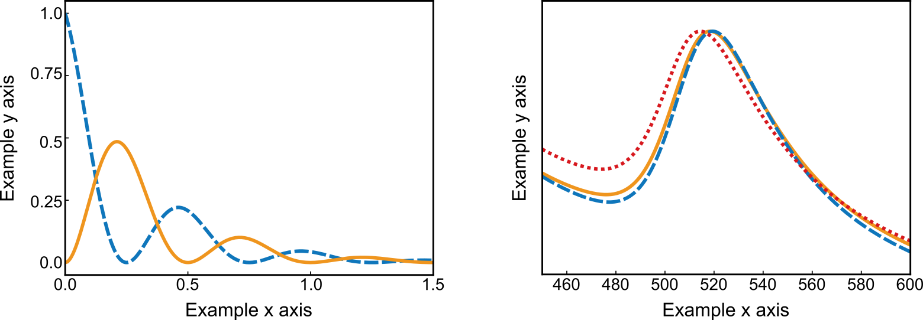
Figure 1: Example figure

References should appear at the end of the article in the order in which they are referenced in the body of the paper. A suggested format for references is given below. Within the main text, references should be designated by a number in brackets [1,2].

References
[1] P. Christopher, H. Xin, and S. Linic, " Visible-light-enhanced catalytic oxidation reactions on plasmonic silver", Nat. Chem. 3, 467–472 (2011)
[2] C. F. Bohren and D. R. Huffman: Absorption and Scattering of Light by Small Particles (Wiley-VCH, Weinheim, 1998)

