How to Do:

Surveys with zoom
  - Quick Reference Guide:
To use polls in Zoom, you must first make the appropriate settings in your User Profile > Settings > In Meeting (Basics) > Meeting Polls. If polls are activated, it is recommended to prepare the poll for the desired meeting. To do this, go to Meetings > Upcoming, find the corresponding meeting, click on the name of the meeting to get to the current settings. At the bottom of the page, click Add to create the survey. In the meeting, you can then start your created poll under "Polls" and share the results with everyone afterwards. Without preparation, you can also create the questions during the meeting under "Surveys" on the bottom bar at Zoom.
Note: The screenshots provided are in German, this was done on purpose as the Moodle Page translations are not complete. We hope that the description and the screenshots will help you in any case!

  - Detailed help: Allow and create surveys in Zoom
1. | Go to your Zoom user profile and log in if necessary
2. | Navigate to Settings in the left tab and "In Meeting (Basics)" in the tab to the right of it | 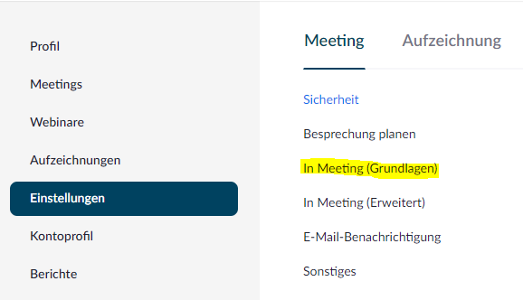
3. | Check the switch under "Meeting poll" if it is blue (activated)
4. | (optional) It is recommended to create polls beforehand so that they can be called up in the corresponding meeting. To do this, click on the name of the desired meeting | 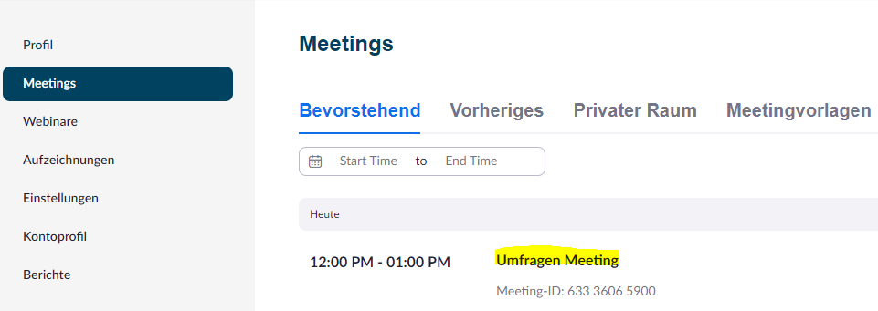
5. | (optional) Click "add" at the bottom of the page to create a new survey (note: you can also create multiple surveys per meeting) | 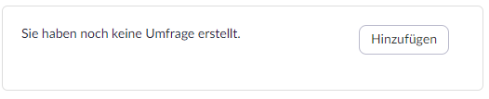
6. | (optional) A window opens to create the survey. You can create one or more questions and specify corresponding answer options. Note that the checkmark for Anonymous should usually be set in order to get honest answers. | 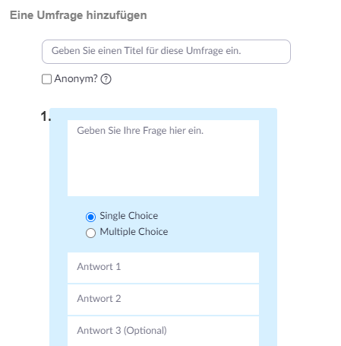
7. | In the meeting, you can create a survey by clicking on "Surveys" or send an already created survey to your participants. There is also the possibility to share the results with the participants after completion. | 