How to Do:

Breakout Session with Zoom - Small Group Work
  - Quick guide:
First of all, before the actual meeting (and also before creating the meeting), you must check here whether "Breakout room" is activated as a function in the "Settings">"Meeting advanced"> "Breakout room".
If this is activated, you can start a breakout session in the meeting itself by clicking on the corresponding icon. Here you can select the number of rooms and divide the participants randomly or as desired to the rooms.
There is also the possibility to divide the participants into subgroups before the meeting. More about this in the detailed help - Define subgroups in advance.
Note: The screenshots provided are in German, this was done on purpose as the Moodle Page translations are not complete. We hope that the description and the screenshots will help you in any case!

  - Detailed help: Switch on Breakout Rooms
1. | Click on this link and log in if necessary. You should be on the settings page of Zoom.UP | 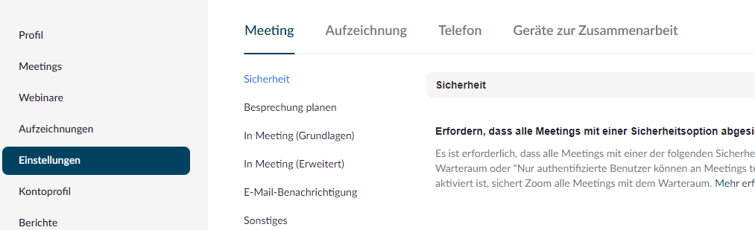
2. | Navigate to Settings > Meeting Advanced | 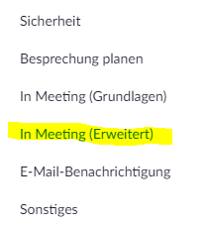
3. | Check whether the check mark is set under Breakout room. If this is the case you can use breakout rooms from now on | 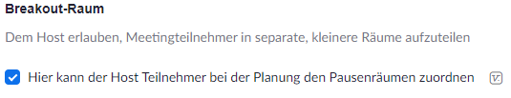

  - Detailed help: Using breakout rooms in meetings
1. | Open Zoom and log in if necessary
2. | During a meeting, you can click on Breakout Session at the bottom of the screen (if you are not in full screen mode, this function may be hidden under "More" (three dots)). | 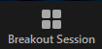
3. | In the appeared window you can choose how many rooms should be created and what kind of assignment to the respective rooms should happen (automatic, manual, left to the participants themselves). Click on Create. | 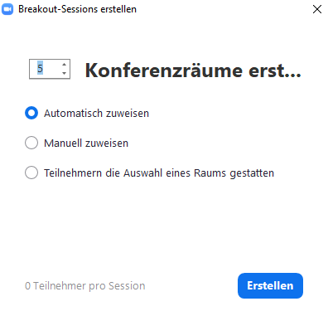
4. | In the next window you have the possibility to rename the rooms (navigate with the mouse on the corresponding bar and click "Rename"), or to add as many additional rooms as you want ("Add a session" click)
5. | (optional) By clicking on "Options" you can set other settings as you like, like a maximum session duration or adjusting the countdown timer
6. | Click on "Start all sessions" to start the created sessions | 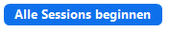
7. | After the sessions have been started (indicated by "In progress" at the top of the bar) you can join the different rooms, send a message to everyone or finally stop the sessions. Depending on the set cooldown timer, it now takes up to 120 seconds until all participants are back in the main room. | 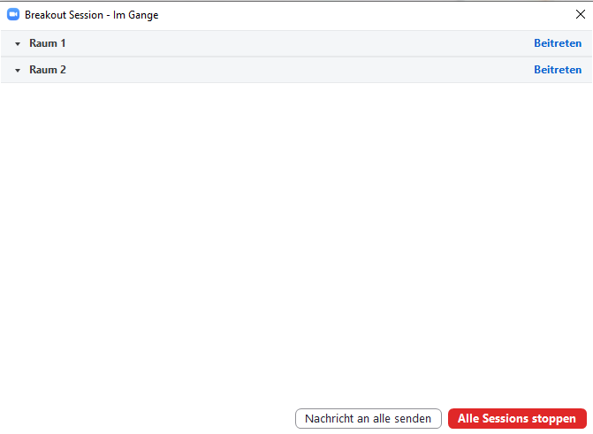

  - Detailed help: Define subgroups in advance
1. | Click on this link and log in if necessary. You should be on the settings page of Zoom.UP
2. | Navigate to Meeting. Here you select the desired meeting in which you wanted to define the subgroups in advance. | 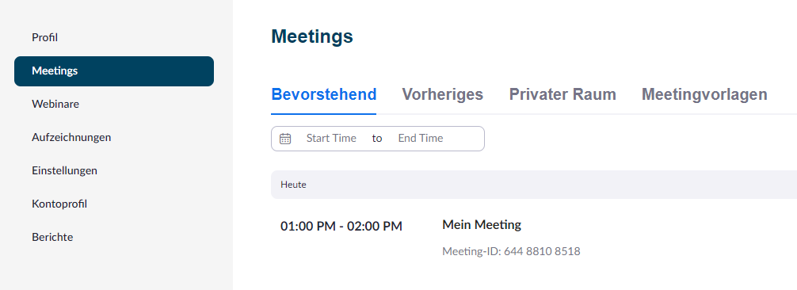
3. | Click on Edit and place a check mark under "Meeting options">Pre-selection of breakout room | 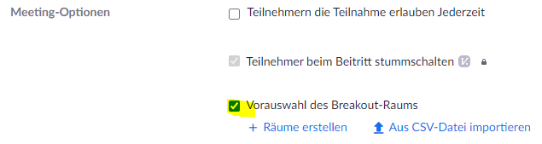
4. | By clicking on the "+" you can now create up to 50 rooms. You can assign your participants to the rooms by means of email addresses. | 